**ELC 5313 Lab Startup Instructions**

Over the course of this semester, we will implement Tomasulo’s algorithm using SystemVerilog, which is a Hardware Description Language.  We will write SystemVerilog code in Vivado and use Vivado’s Behavioral Simulation capabilities to test the behavior of the hardware that is produced by our SystemVerilog code.  Vivado is a program that allows us to simulate and synthesize our Verilog code.

It is very important to keep the Verilog code separate from the Vivado project.  We never want these two sets of files to mix…they should always be stored in distinctly different directories.  These two file sets are:

1. ELC5313-Lab – these files include your SystemVerilog code, lab reports, tables, lab manual, etc.  This is your work that you don’t want to lose and that you will turn in.
2. ELC5313-Project – these are project files used by Vivado when synthesizing and simulating.  This is not your work and you will never turn these in.  They are just data files, temporary files, etc that Vivado creates and uses.  These files are expendable.  You can always easily create a new project and reproduce your results as long as you can reference your ELC5313-Lab directory.

**ELC5313-Lab Instructions**

1. In a web browser, go to the following address:
   1. <https://github.com/BaylorComputerEngineering/ELC5313>
2. Click on ‘Code’, then click on the ‘Copy to clipboard’ icon.
3. Open the Box Drive app and log in (this will require two factor authentication).  Once logged in, you should be able to access your Box files through Windows Explorer as shown below.  These files are located at C:/users/your_user_name/Box
4. In the Box directory, create a new directory called ELC5313 and go into this directory.
5. Then create a directory called ‘ELC5313_OG’ and go into this directory.
6. In the white space of this explorer window, right-click and select ‘Show More Options’, then select ‘Git Bash Here’, as shown below

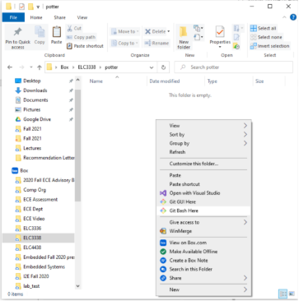

1. The Git Bash application gives you command-line access to Git.  Do the following in Git Bash:
   1. git clone <paste here the URL you copied in GitHub>
      1. Do not include the < > in your command.  I just used those for clarity.
      2. If you are asked for a password, then you will need to create and use a Personal Access Token and use it as the password.  See instructions at:
         1. <https://docs.github.com/en/github/authenticating-to-github/keeping-your-account-and-data-secure/creating-a-personal-access-token>
      3. If you get an error that says you are unable to access the repository, run the following command:
         1. git config --global http.sslverify false
2. The repository you just cloned is my repository, not yours.  I will use it to give you files, so you should never modify any files in the ELC5313_OG/ELC5313-Lab directory.  Instead, open another Windows File Explorer window and navigate back to Box/ELC5313.  Copy the ELC5313-Lab directory from the Box/ELC5313/ELC5313_OG directory and paste it into Box/ELC5313.  This version of ELC5313-Lab in Box/ELC5313 is where you will do your work throughout the semester.
   1. Never update files in the ELC5313_OG directory.  For every lab, I will give you new files via updating the ELC5313_OG directory.  If you make any changes in the ELC5313_OG directory, you will have problems getting the updates.  To get updates in the future:
      1. Navigate to ELC5313/ELC5313_OG/ELC5313-Lab in Git Bash
      2. git pull
      3. Then copy any updated files that you need from ELC5313/ELC5313_OG/ELC5313-Lab to ELC5313/ELC5313-Lab.  Use your discretion on which files you want to copy into your directory, as you do not want to copy my entire repository and overwrite yours.

**ELC5313-Project Instructions**

1. On your PC, open Vivado.
2. Under Quick Start, choose ‘Create Project’
3. Use ‘ELC5313-Project’ for your Project name.
4. For your ‘Project location’, select C:/users/your_user_name/Box/ELC5313 (do NOT navigate all the way into the ELC5313-Lab directory!)
5. Keep ‘Create Project Subdirectory’ checked and click Next.
6. Select RTL Project and click Next.
7. On the ‘Add Sources’ dialog, select ‘Add Directories’ and select your ‘code’ directory in ELC5313/ELC5313-Lab directory
8. Click ‘Next’ through the rest of the menus, then click ‘Finish’ when available.

**Speeding up Simulation Time**

1. To speed up simulation, we can force Box to download the files to the computer when we log in by right-clicking and selecting the ‘Make Available Offline’ option for both ELC5313-Project and ELC5313-Lab.
2. This copies the files from the cloud (Box) to your local hard drive, greatly speeding up simulation time
3. The files will still be updated to the cloud, but it will not affect performance.

**Using Vivado** (UPDATE W ADDER EXAMPLE)

1. In the ‘Sources’ pane, right-click on adder_t.sv and select ‘Set as Top’
2. On the left side of the screen, right click on ‘SIMULATION’ and select ‘Simulation Settings’.

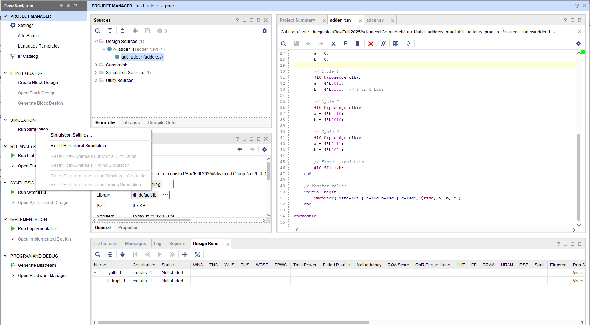

1. In the Simulation Top Module Field, select adder_t and click Ok to apply the top module change.
2. Review the source code of adder.sv and adder_t.sv
3. Click on ‘Run Simulation’ and select ‘Run Behavioral Simulation’ as shown below.  If a window pops up asking for Networking/Firewall access, just select ‘Cancel’.

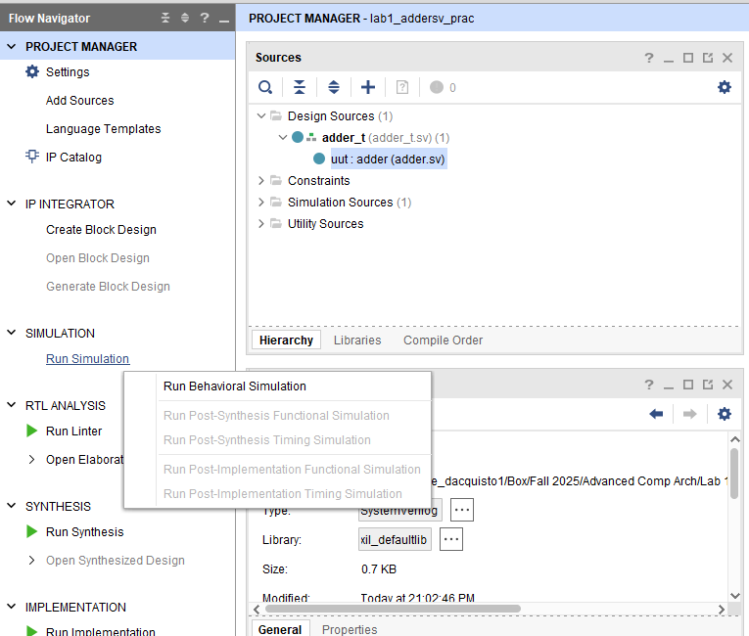

1. On the Simulation graph, use the ‘Zoom Fit’ button (four arrows pointing to corners) to see the first ns so that you can see what is happening.  Please set the Radix to Signed Decimal using the settings icon at the top right.

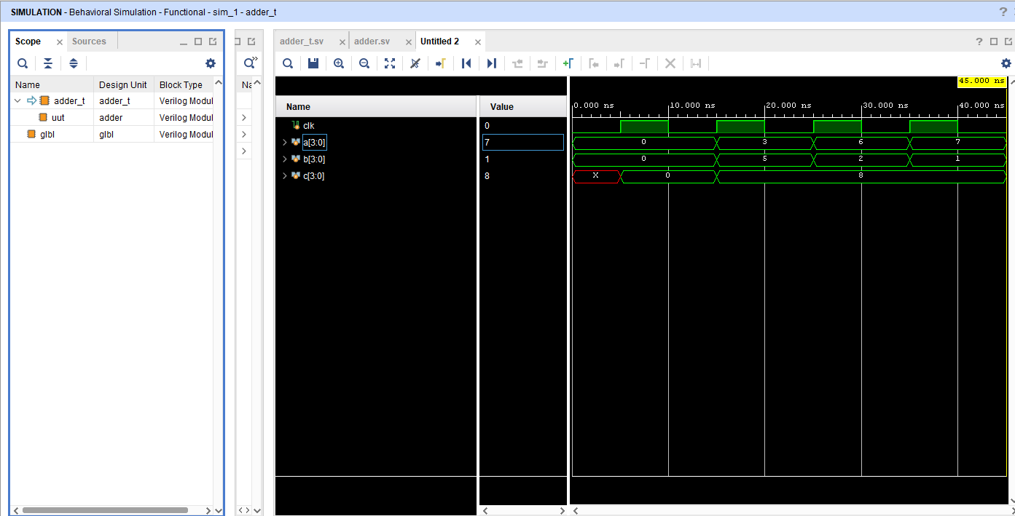

IMPORTANT NOTE: When you run your simulation, modify code, and then want to re-run the simulation with your changes, you can simply click the ‘Relaunch’ button near the top-middle of the screen.